**Demo Pages of ENTNT Assignment**

Dashboard Page

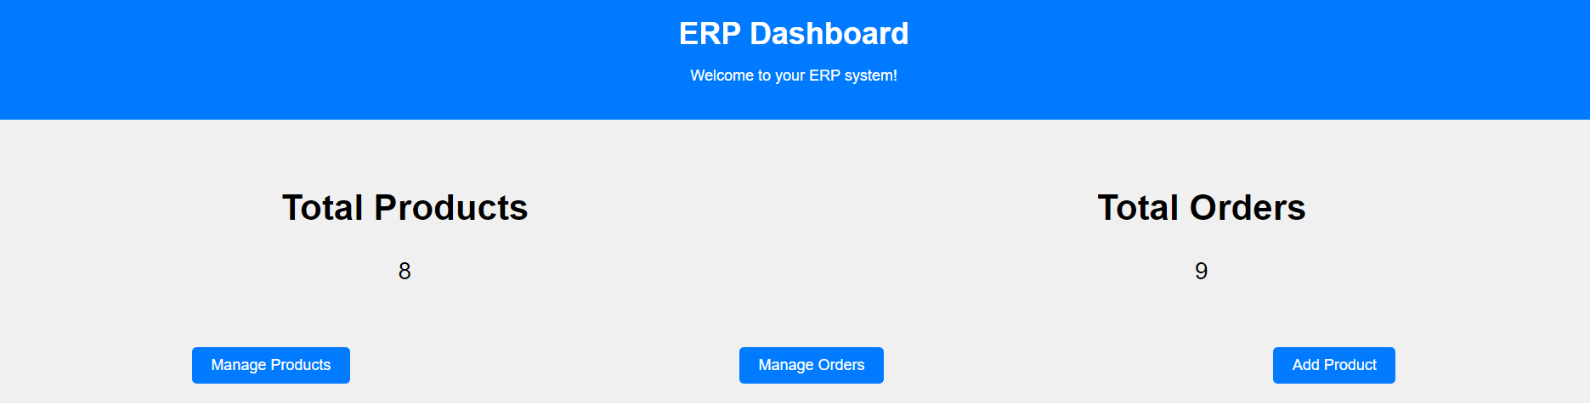

Manage Products Page

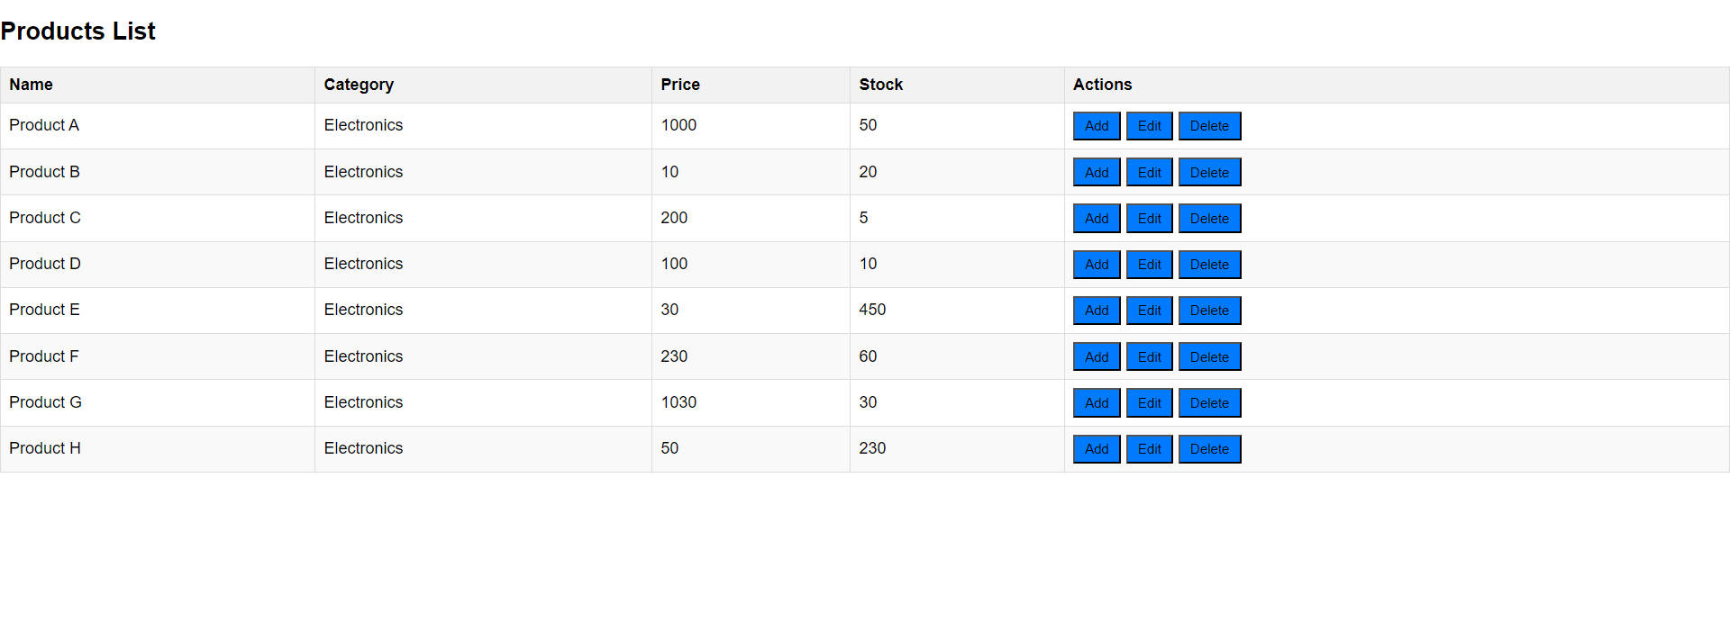

When user clicks on Add Button

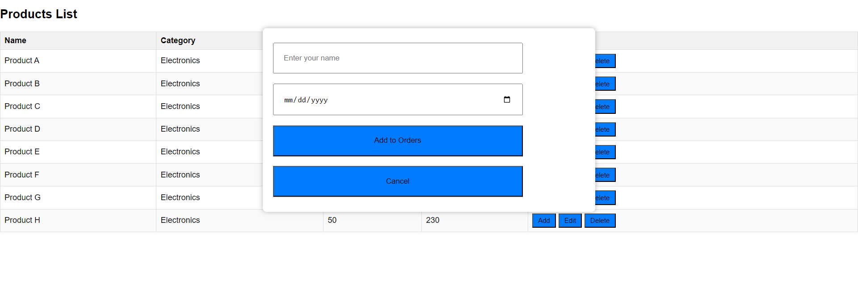

When user fills details like name and date and then clicks on Add to Orders button will display

Orders Page

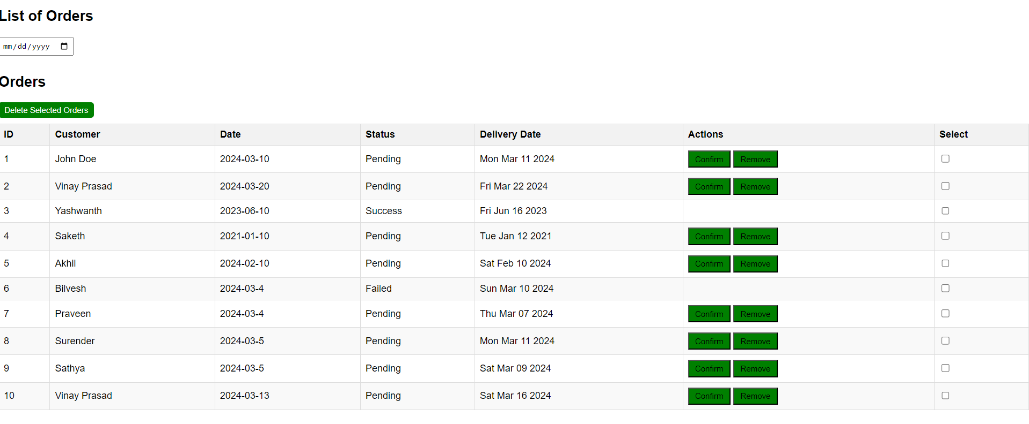

If we clicks on confirm/remove status of the particular order will change to Success/Failed.



We can select the orders to delete from orders page after selecting click on delete selected products to remove from orders page.

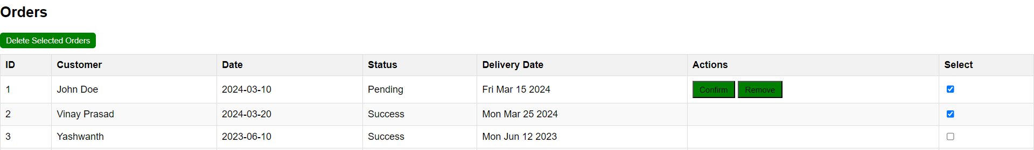

Select the particular date to display the orders of that particular date

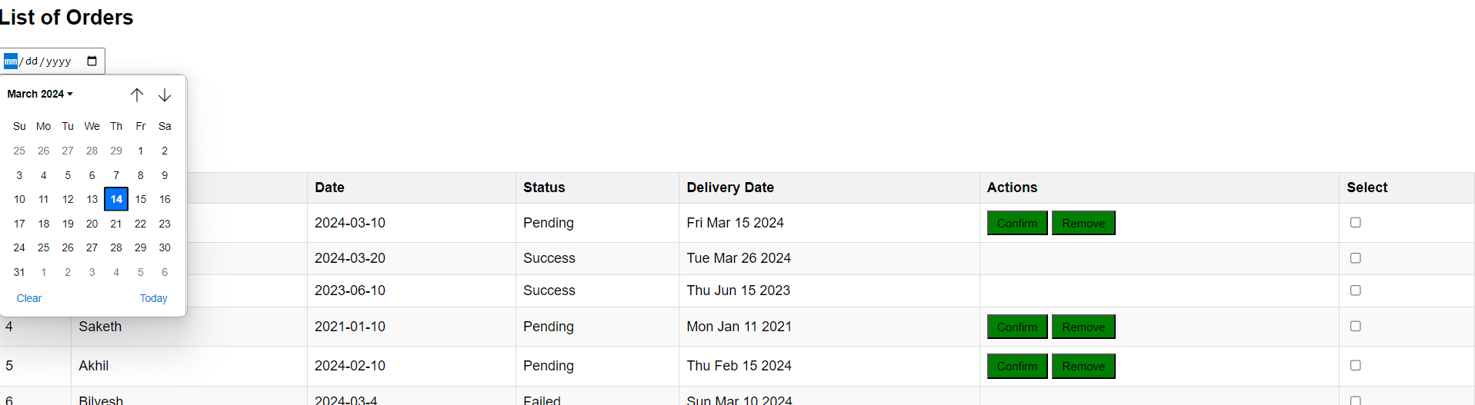

When user clicks on Edit button in Products List page the add product page will display the pre-filled details

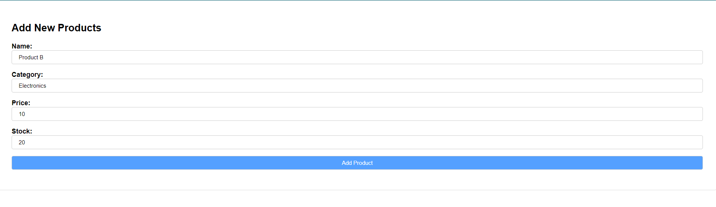

When user clicks on delete button from Products List page

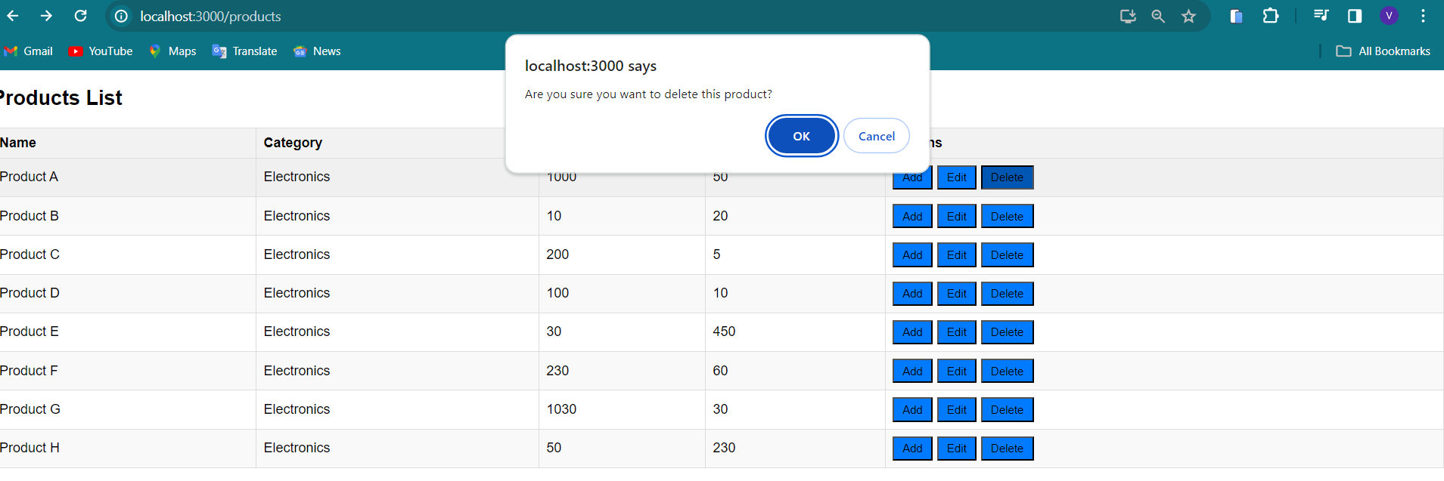

After clicking Ok the product is removed from Products List page.

When user clikcs on Add Products page from Dashboard page

